Moving to a New City

# Introduction:

In today’s world, people relocate to new cities for various reasons like higher studies, job opportunities etc.

When someone decides to move to any new city, it will be good for them to get an idea about the neighborhoods in that city, how safe those neighborhoods are and what kind of venues they have like restaurants, supermarkets, shopping places, fitness centers or parks and beaches etc.

In this project, we will identify and compare neighborhoods in **Chicago** on the basis of various criteria such as safety being the highest priority for anyone and then other facilities available around safer neighborhoods.

# Data Sources:

* **Wikipedia :** <https://en.wikipedia.org/w/index.php?title=Community_areas_in_Chicago&diff=952586757&oldid=952586127>

This page has list of all community areas and neighborhoods in respective community areas. We will perform web scraping and prepare dataset out of it.

* **Chicago Data Portal** (<https://data.cityofchicago.org/Public-Safety/Crimes-2001-to-present/ijzp-q8t2>) :

This data portal has many datasets related to Chicago city. We will use the Chicago crime dataset. This dataset has updated information about crimes happened in the Chicago, type of crimes, community area in which crime was reported etc.

We will use data since year 2017 and find out the safer community areas considering number of crimes reported in each area.

Then we will get the list of neighborhoods in those community areas and perform further analysis depending on various venue categories one may be interested in.

* **FourSquare API**:

We will use FourSquare API to retrieve various venue categories available around the neighborhoods and categorize areas for most popular venues in a particular neighborhood.

# Data Wrangling:

1. Dataset containing list of community codes, community areas and list of neighborhoods.

Below is the sample data available on Wikipedia page.

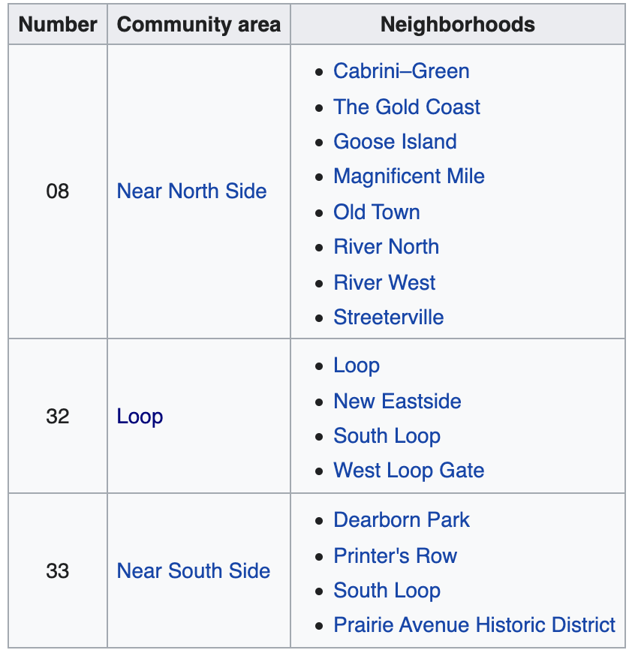

We have scrapped the webpage using Python library Beautiful Soup and prepared a

pandas dataframe which is as below:

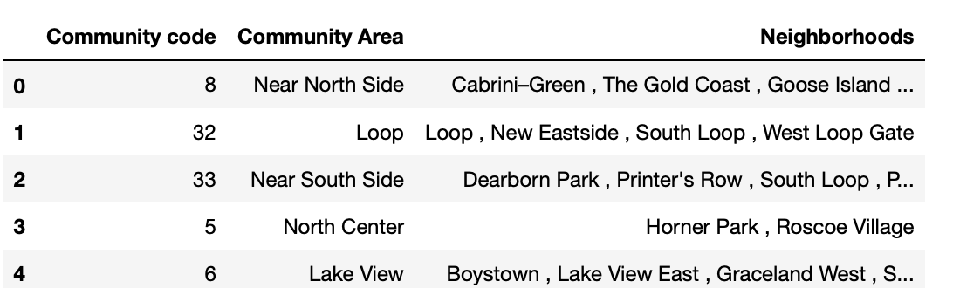

There were few community codes and community areas combinations for which neighborhood column was empty. Below are few examples of such combinations.

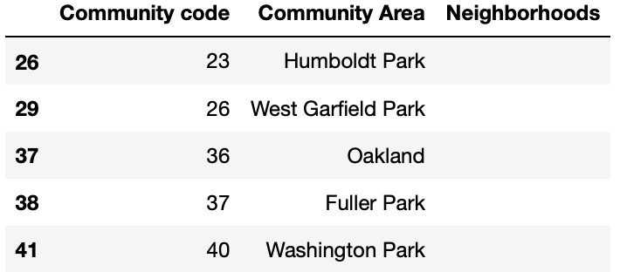

For such cases, Neighborhoods column is populated with respective community area name.

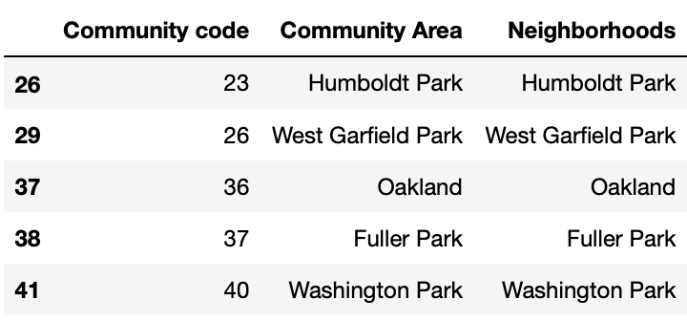

There are total 77 community areas in Chicago.

1. Chicago crime dataset:

We have downloaded this dataset after filtering it for year > 2016. Therefore, it contains crime data from year 2017 up to present day(day when dataset was downloaded this year).

This dataset contained ‘Not A Number’ i.e. NaN values in few cells as shown below:

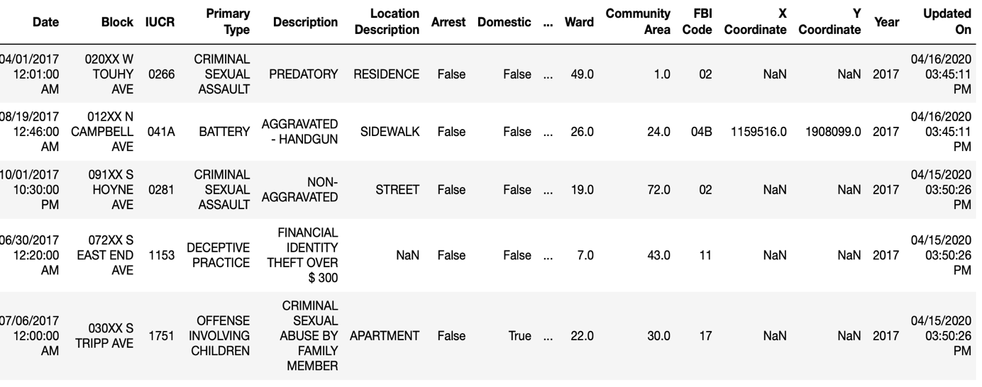

Therefore, dataset was modified to ignore such rows using **dropna** function available in pandas.

# Methodology:

Our aim is to identify the safer neighborhoods in Chicago city and then analyze and categorize them based on venues available around them.

We will follow below steps to accomplish our task.

1. From Chicago crime database, we will find out 15 community areas which have less

number of crimes reported compared to other community areas and list them as safer

community areas.

We have also performed some exploratory data analysis for crime data.

1. From Community Areas dataset which was prepared using data available on Wikipedia,

retrieve subset for safer community areas identified in step 1.

1. Get the location longitude and latitude for these safer community areas.
2. Once location coordinated are known, use Foursquare API to get the venue categories

around each community area.

1. List top 10 most popular venue categories for each community area.
2. Apply **K-mean clustering** to perform clusters out of these community area and then analyze the results.

# Results:

Outputs for each of the step mentioned in Methodology:

1. Below are the types of crimes reported in Chicago city.

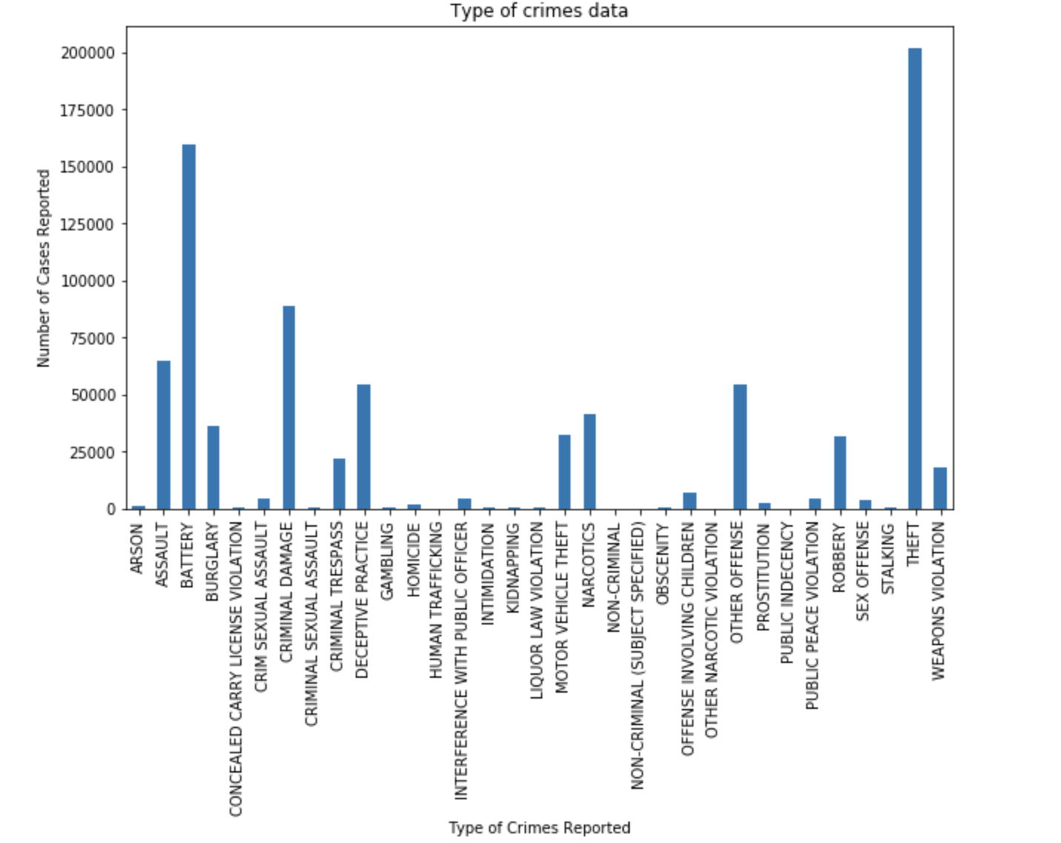

From above plot, we have **top 5 types of crime** reported as Theft, Battery, Criminal Damage,

Assault and Deceptive Practice.

Considering number of crimes reported in each area, below are the top 15 areas identified as safer community areas.

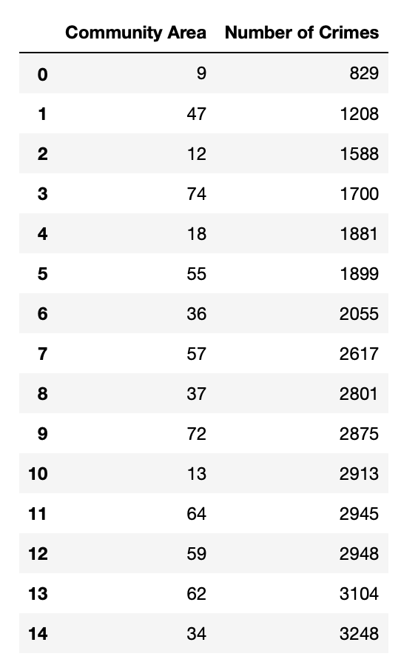

List of safer communities : [9, 47, 12, 74, 18, 55, 36, 57, 37, 72, 13, 64, 59, 62, 34].

Below is the plot for top 5 crime types reported in safer community areas.

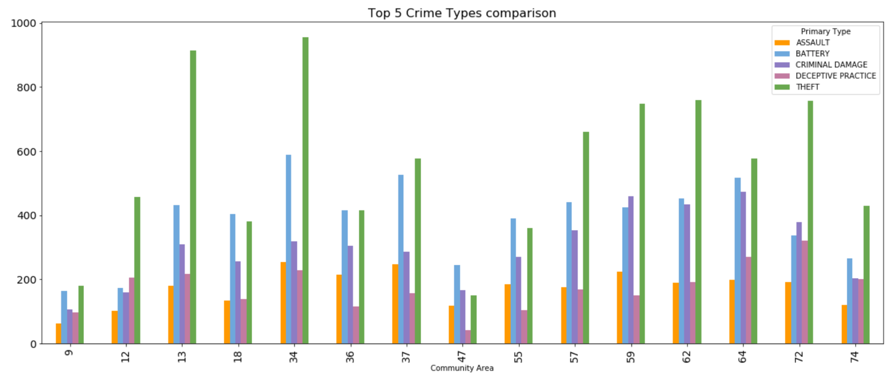

1. Community codes, Community Areas and List of their neighborhoods for safer communities identified in above step.

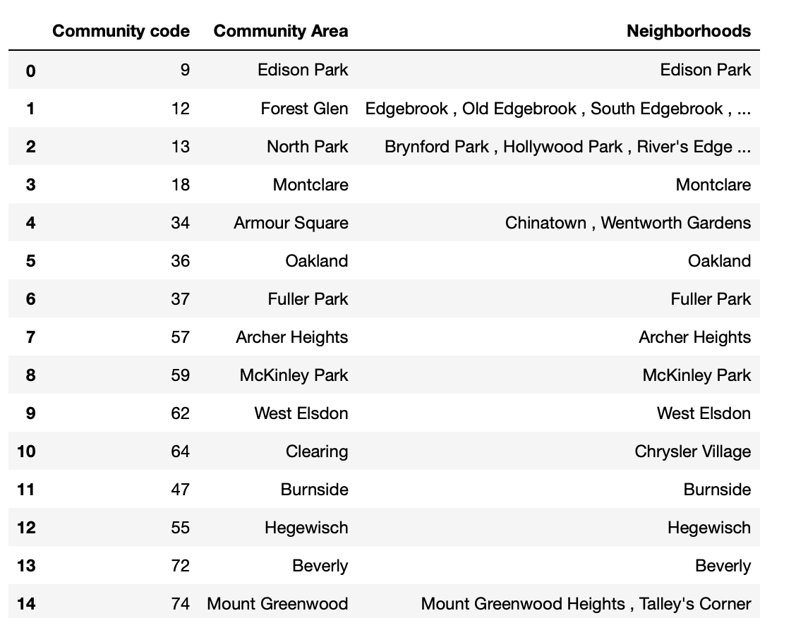

1. Using Geopy client for geocoding web services, location coordinated are obtained for each of the community area listed in above step 2.

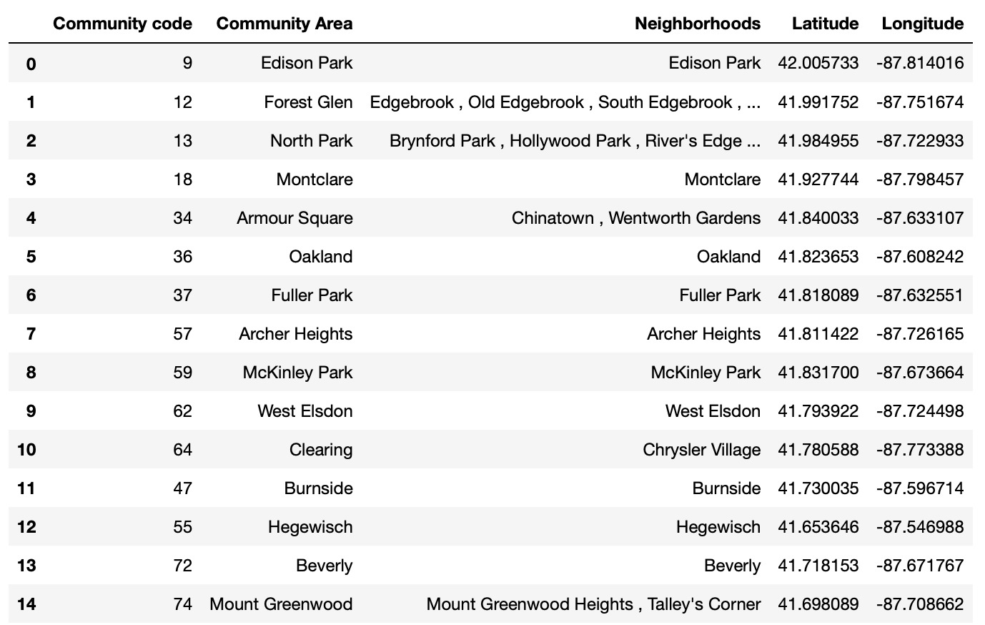

Using Folium map, we plotted these community area locations on map as below:

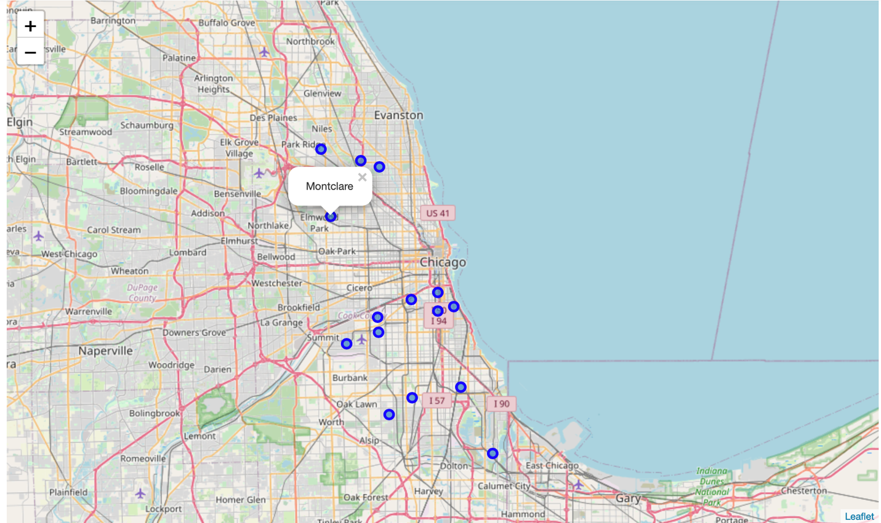

1. Using Foursquare API, we have found venue categories around safer community areas.

To use Foursquare API, We need to form a URL containing search query for venue categories, Client ID, Client secret key, location coordinates around which we need to get venues, RADIUS around the coordinates and LIMIT(Maximum number of venue categories to retrieve)

We have set Radius = 5000 and Limit = 100 here.

Below is the sample dataset we get as output returned by Foursquare API.

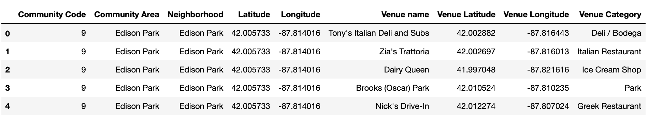

There are 195 unique venue categories returned using above mentioned radius and limit around safer community area locations.

1. After performing some further technical modifications, we listed the top 10 most popular venue categories for each community area.

1. **Clustering using K-means** : We have used K-means clustering method to divide the community areas in **3 clusters** in order to perform cluster analysis.

K-means is a popular **unsupervised machine learning algorithm** that aims to partition n observations into k clusters in which each observation belongs to a cluster with the nearest mean, serving as a prototype for the cluster.

Below is the sample dataset we obtained after performing K-means clustering.

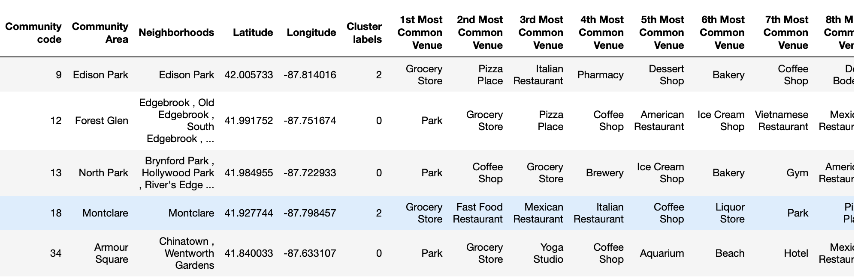

Each community area is assigned a cluster label as 0,1 or 2.

We plotted the same using Folium maps as below:

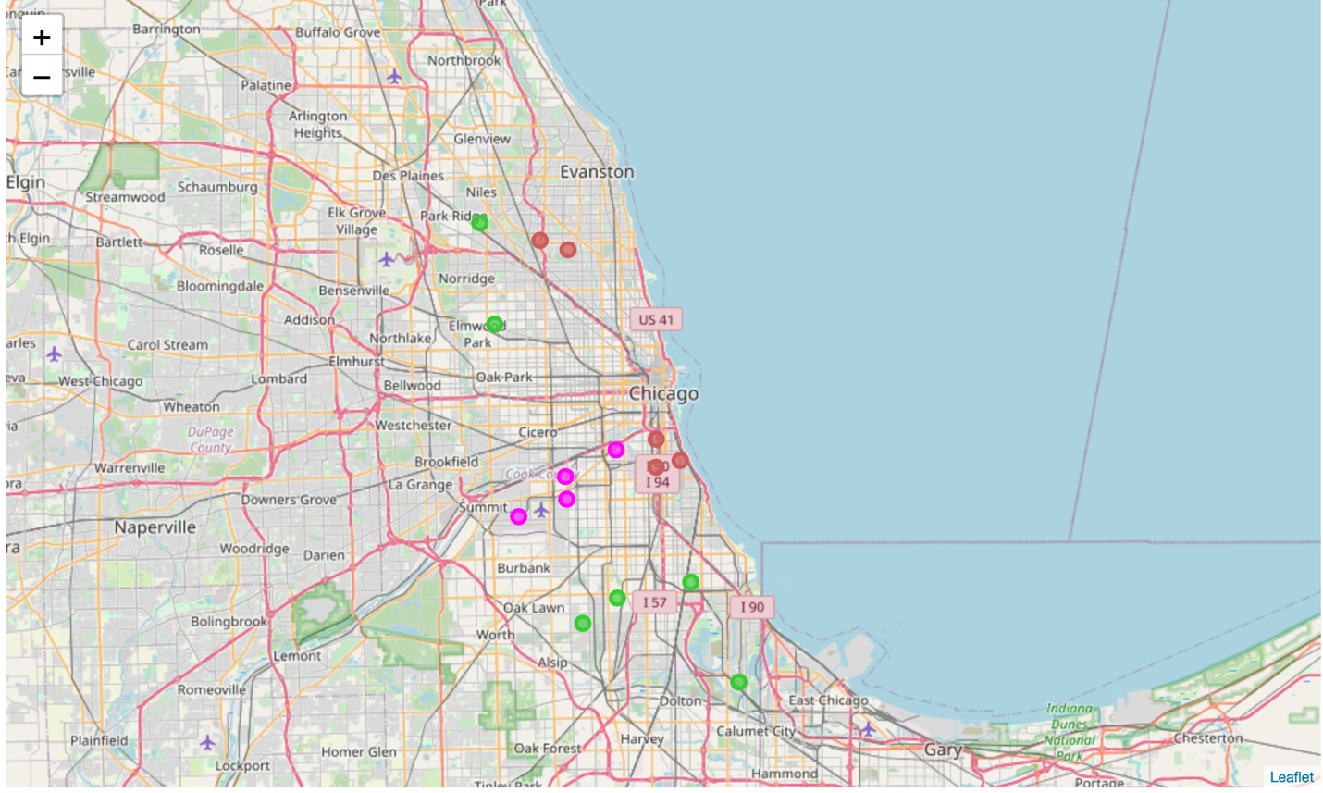

# Discussion:

We have analyzed each cluster to find out the common categories based on which clustering has been done.

Cluster 0:

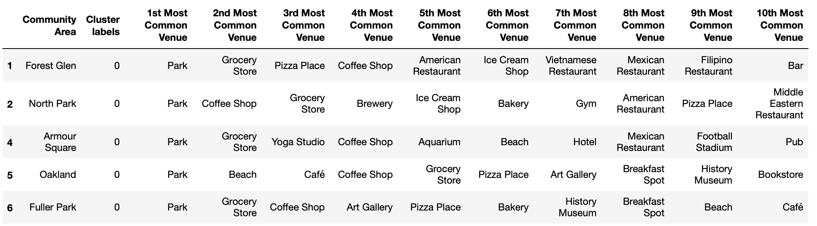

As we can see, 1st most common venue for community areas under cluster 0 is Park.

Then we have grocery store, pizza place and coffee shops in each area.

Three of the five areas have beach while two of the five have Breakfast spots.

Either Yoga studio or gym or park are present in each area if someone is interested in regular fitness activities.

For people interested in Arts and History, there are Arts galleries and History museums.

Cluster 1:

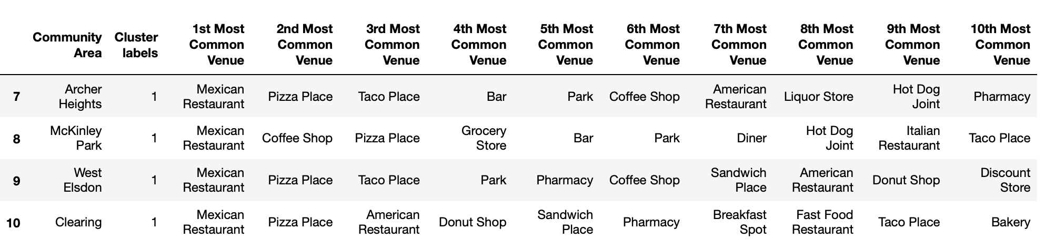

As one can clearly observe that cluster 1 areas have Mexican restaurants, Pizza places and taco places as their most common venues.

Cluster 2:

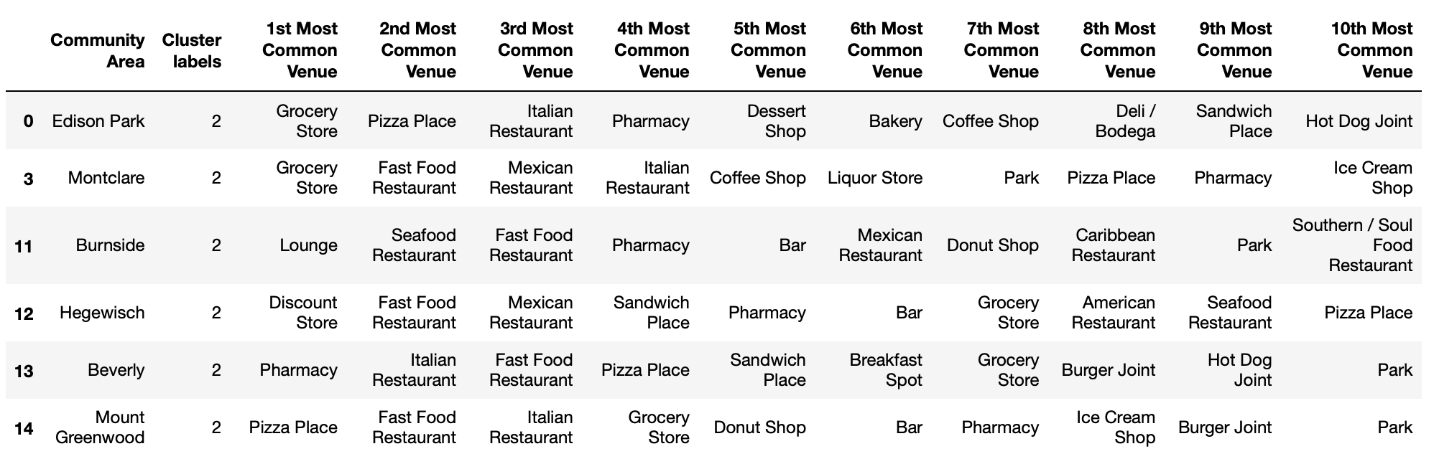

Cluster label 2 has Pharmacy and grocery store as most common venues. Apart from these two, we have Fast Food Restaurant, Italian Restaurant and Mexican restaurant as another most common venue categories.

# Conclusion:

After analyzing the clusters, we can conclude that areas in cluster 1 i.e. with cluster label = 0 have good combination of venues such as restaurants, grocery stores, beach, park, fitness activity centers(Yoga Studio and Gym), and it also has Art galleries and museum. So it covers most of the interests one might have.

Here, we considered Chicago as a new city but this approach can be followed for any other cities and one will be able to choose the neighborhoods around any city depending on one’s interests.